 | Course Name: Design Patterns/Thinking LAB | EXPERIMENT NO. 2
 | Course Code: 20CP210P Faculty: Dr. Payal Chaudhari | Branch: CSE | Semester: IV
(To be filled by Student) Submitted by: Meet Jain
Roll no: 23BCP093

Objective: To familiarize students with standard Creational design patterns.
Experiment: Explain the abstract factory design pattern and write a program using any object-oriented programming language to demonstrate the working of abstract factory design pattern.
Theory

Abstract Factory is a creational design pattern that lets you produce families of related objects without specifying their concrete classes. That means Abstract Factory lets a class returns a factory of classes. So, this is the reason that Abstract Factory Pattern is one level higher than the Factory Pattern.

An Abstract Factory Pattern is also known as Kit.

Advantage of Abstract Factory Pattern
- Abstract Factory Pattern isolates the client code from concrete (implementation) classes.
- It eases the exchanging of object families.
- It promotes consistency among objects.

Code

import java.util.Scanner;

class SuperFoodFactory{
static FoodFactory getFoodFactory(String mode){
if(mode.equals("Pizza")){
return new PizzaFactory();
}
else if(mode.equals("Drink")){
return new DrinkFactory();
}
else{
return null;
}
}
}

interface Eatable{
public void serve();
}

abstract class FoodFactory{
abstract Eatable servefood();
}

class PizzaFactory extends FoodFactory{
Eatable servefood(){
System.out.println("Paneer or Cheese:");
try (Scanner sc = new Scanner(System.in)) {
String pizza = sc.nextLine();
if(pizza.equals("Paneer")){
return new PaneerPizza();
}
else{
return new CheesePizza();
}
}
}
}

class DrinkFactory extends FoodFactory{
Eatable servefood(){
System.out.println("IceTea or Coffee:");
try (Scanner sc = new Scanner(System.in)) {
String drink = sc.nextLine();
if(drink.equals("Coffee")){
return new Coffee();
}
else{
return new Icetea();
}
}
}
}

class PaneerPizza implements Eatable{
public void serve(){
System.out.println("Paneer Pizza is served");
}
}
class CheesePizza implements Eatable{
public void serve(){
System.out.println("Cheese Pizza is served");
}
}

class Coffee implements Eatable{
public void serve(){
System.out.println("Coffee is ready ");
}
}

class Icetea implements Eatable{
public void serve(){
System.out.println("Icetea is ready");
}
}

public class Main{
public static void main(String args[]){
System.out.println("Choose option from: \n1.Pizza: \n2.Drink: ");
try (Scanner s = new Scanner(System.in)) {
String choice = s.nextLine();
FoodFactory foodfact = SuperFoodFactory.getFoodFactory(choice);
Eatable food = foodfact.servefood();
food.serve();
}
}
}

Output:

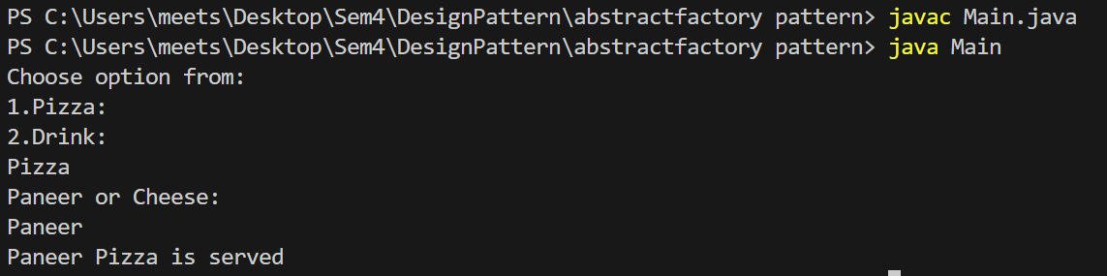

Class Diagram:

